SOCI E-143

REFUGEES:

FORCED MIGRATION IN GLOBAL PERSPECTIVE

Fall 2022
Lecture Time: Wednesdays, 6-8pm.
Location: ZOOM

Section Time: Class Sections have a following rotating schedule:
- Sep. 9th, Friday 7pm
- Sep. 15th, Thursday 5pm
- Sep. 23rd, Friday 1pm
- Sep. 30th, Friday 7pm
- Oct. 6th, Thursday 5pm
- Oct. 14th, Friday 1pm
- Oct. 21st, Friday 7pm
- Oct. 27th, Thursday 5pm
- Nov. 4th, Friday 1pm
- Nov. 10th, Thursday 5pm
- Nov. 18th, Friday 1pm
- Nov. 25th, Friday 7pm
Location: ZOOM

Professor:
Danilo Mandić
604 William James Hall

Office Hours: 14:00-15:00 on Zoom
Email: mandic@fas.harvard.edu

Teaching Fellows:

Aleksandar Jakovljević

Office Hours: By appointment
Email: aleksandar_jakovljevic@hks.harvard.edu

Course Abstract

Who is a refugee? Where do they come from, and why? How are they displaced? What are we going to do when massive refugee waves become “the new normal”? This course will inquire into the nature, causes and consequences of contemporary refugee waves in our globalized world. Students will survey regional dynamics in the Middle East, Africa, Asia, Europe and the Americas. We will examine the particularities of refugees (compared to other migrants) and the changing nature of forced migration since the Second World War. Students will explore historical precedents to contemporary waves, learn about different host society approaches to asylum, compare government and criminal mechanisms of forced migration, and examine the reasons refugees are the object of increasing suspicion and hostility around the world. Particular attention will be paid to the recent EU crisis, the role of refugee camps in the 21st century, and alternative strategies for global asylum management by bridge and destination countries.

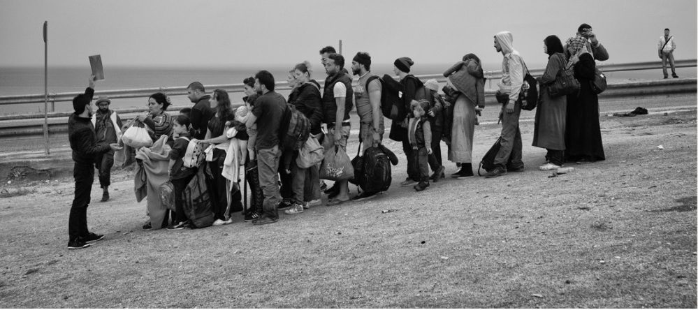
Photo Courtesy of Macek Nabrdalik

THE PHENOMENON AT A GLANCE

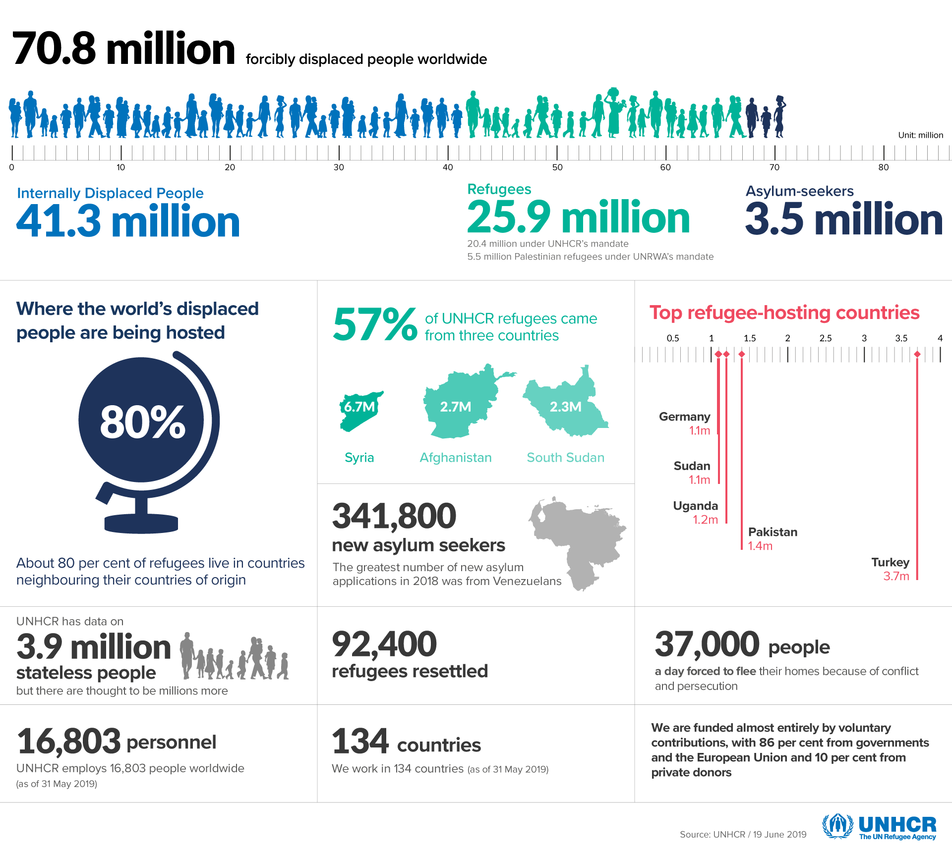
We are now witnessing the highest levels of displacement on record.

An unprecedented 70.8 million people around the world have been forced from home. Among them are nearly 25.9 million refugees, over half of whom are under the age of 18.

There are also millions of stateless people who have been denied a nationality and access to basic rights such as education, healthcare, employment and freedom of movement.

Course Requirements

It is imperative that students attend class and engage actively in class discussion. Four unexcused absences from class will result in an automatic “Fail” grade (including for pass/fail students). Whenever possible, please send your TF documents from Health Services, your coach, RA, etc. for excused absences. Please be in touch with course head regarding COVID or other health emergencies and we will do our best to accommodate.

Attendance (mandatory) (10%)
Class Discussion (mandatory) (20%)
Weekly Quote Selection & Response (30%)
Policy Memo (15%)
Final Paper (25%)

Each week students will submit a quote (no more than one paragraph) on Canvas’s Assignments Tab from one of the weekly readings and a brief question or comment about the issue at hand. Responses to the quotes should be 3-5 sentences minimum and no more than two paragraphs. Quotes and responses must be submitted through the Assignments Tab on the course website each Monday at before noon (i.e. 11:59am). Late quote responses will not be accepted. Submitted quotes and questions/comments will be discussed in section. These assignments will be graded on a simple -/+/++ basis.

Approximately mid-way through the course, students will write a policy memo (5 pages). In the memo, students will identify a particular policy challenge of modern forced migration (e.g. country refugee quotas, drownings in the Mediterranean, human rights of disabled migrants, labor market integration, anti-migrant extremist groups, refugee trauma) and propose an original, creative solution (through legislation, civic engagement, electrical engineering, computer apps – be creative!). Students are expected to research their selected policy challenge, and to put thought into the feasibility of their proposal. The memo will be in lieu of the weekly quote response.

In the final paper (10 pages), students will compare two refugee constituencies in two different regions (e.g. Syrian refugees in Greece with Vietnamese refugees in Australia, or Nicaraguan refugees in the US with Bosnian refugees in Turkey) to address a research question about today’s global forced migration. The papers are expected to present an explanatory argument addressing the research question, applying readings from the syllabus. Final paper topics and research questions must be approved by the instructor two weeks prior to the deadline.

N.B. For graduate-level credit, students will produce a 20-page final project. Topic and scope should be approved mid-semester, and in consultation with the course head.

Every two weeks, there will be a regional case study theme (Middle East, Africa, Europe, North and Latin America, Asia and South Pacific).

Late Policy for Deadlines

One partial grade will be deducted from policy memos and final papers that are turned in late (for example, an A- paper would be given a B+). Another partial grade will be taken off for each additional 24 hours of tardiness. Extensions will be given in the case of medical emergencies or religious observance. All requests for extensions should go directly to the course head and must be made in advance of the relevant deadline.

Accommodation Requests

Harvard Extension School is committed to providing an inclusive, accessible academic comm nity for students with disabilities and chronic health conditions. The Accessibility Services Office (ASO) (https://extension.harvard.edu/for-students/support-and-services/accessibility-services/) offers accommodations and supports to students with documented disabilities. If you have a need for accommodations or adjustments, contact Accessibility Services directly via email at accessibility@extension.harvard.edu or by phone at 617-998-9640.

Academic Integrity

You are responsible for understanding Harvard Extension School policies on academic integrity (https://extension.harvard.edu/for-students/student-policies-conduct/academic-integrity/) and how to use sources responsibly. Stated most broadly, academic integrity means that all course work submitted, whether a draft or a final version of a paper, project, take-home exam, online exam, computer program, oral presentation, or lab report, must be your own words and ideas, or the sources must be clearly acknowledged. The potential outcomes for violations of academic integrity are serious and ordinarily include all of the following: required withdrawal (RQ), which means a failing grade in the course (with no refund), the suspension of registration privileges, and a notation on your transcript.

Using sources responsibly (https://extension.harvard.edu/for-students/support-and-services/using-sources-effectively-and-responsibly/) is an essential part of your Harvard education. We provide additional information about our expectations regarding academic integrity on our website. We invite you to review that information and to check your understanding of academic citation rules by completing two free online 15-minute tutorials that are also available on our site. (The tutorials are anonymous open-learning tools.)

Equity and Inclusion

We commit to make lectures and sections a precious venue where to learn, encounter different perspectives, and explore our emotional and intellectual response to the readings. We will create a community of dialogue where we exchange ideas and where everyone, further than participating, will train in taking care of others’ presence and participation. Therefore, paying attention to the fact that everyone has a chance to express their thoughts and -if not- considering in which ways -if any- we hinder them to do that, will be a relevant exercise. Learning and dialoguing could require a high level of exposure: we will collaborate in guaranteeing our class to be a safe place where disagreements and doubts are opportunities to learn. We won’t tolerate any shame/discriminatory/judging behaviors.
Acknowledging that learning is a process that each of us navigate with different pace, method, and style, we would listen your concerns and proposals for particular accommodations. All discussions on accommodations will remain confidential.

Readings

Articles and book chapters are available on the course website. The following books are available on reserve at Lamont Library:

Bhabha, J., 2014. Child migration and human rights in a global age. Princeton University Press.

Fiddian-Qasmiyeh, E., Loescher, G., Long, K. and Sigona, N. eds., 2014. The Oxford Handbook of Refugee and Forced Migration Studies. OUP Oxford.

Gold, S.J. and Nawyn, S.J., 2013. Routledge international handbook of migration studies. Routledge.

Hollifield, J., Martin, P. and Orrenius, P., 2014. Controlling immigration: A global perspective. Stanford University Press.

Zolberg, A.R. and Benda, P.M., 2001. Global migrants, global refugees: problems and solutions. Berghahn Books.

Online Resources

➔ Migration Policy Centre
http://www.migrationpolicycentre.eu/migrant-crisis/

➔ United Nations Refugee Agency (UNHCR)
www.unhcr.org.

➔ International Organization for Migration (IOM)
http://www.iom.int/

➔ Refugees Studies Centre
https://www.rsc.ox.ac.uk/

Course Outline

Class 1 (August 31st):
Introduction

Watters, C. and Nawyn, S. 2013. “Refugees and Forced Migrants,” in Gold, S.J. and Nawyn, S.J., 2013. Routledge international handbook of migration studies. Routledge, pp. 97-118.

Castles, S., 2003. Towards a sociology of forced migration and social transformation. sociology, 37(1), pp.13-34.

Skran, C. and Daughtry, C.N., 2007. The study of refugees before “Refugee Studies”. Refugee Survey Quarterly, 26(3), pp.15-35.

Gibney, M. 2015. “Refugees and Justice Between States” in European Journal of Political Theory, pp.448-463.

Recommended:

Mandic, D. 2021. "What is the force of forced migration? Diagnosis and critique of a conceptual relativization." Theory and Society (2021): 1-30.

N.B. A short “skills-check” assignment will be administered during the first class, asking students to briefly react to the readings’ themes.

Class 2 (September 7th):
The Shadow of the World Wars

Gatrell, P. 2008. “Refugees and Forced Migrants during the First World War,” Immigrants & Minorities, 82-110.

Bade, K.J. “The Second World War and the Post-War Decade” in Migration in European History, pp.204-216.

Wyman, D. S. 2007. “Late and Little” in The Abandonment of the Jews: America and the Holocaust, 1941-1945, pp. 255-287.

Gibney, M.J. 2006. “’A Thousand Little Guantanamos’: Western States and Measures to Prevent the Arrival of Refugees” in Displacement, Asylum, Migration, pp.139-169.

Zolberg, A.R., Suhrke, A. and Aguayo, S., 1986. International factors in the formation of refugee movements. International Migration Review, pp.151-169.

Class 3 (September 14th):
Imperial Legacies, Modern Wars

REGIONAL CASE STUDY: MIDDLE EAST

“Forced Migration in the Middle East and North Africa” in Fiddian-Qasmiyeh, E., Loescher, G., Long, K. and Sigona, N. eds., 2014. The Oxford Handbook of Refugee and Forced Migration Studies. OUP Oxford, pp. 1-10.

Tirman, J. 1997. “The Terrible Reckoning: Turkey’s ‘White Genocide’” in Spoils of War: The Human Cost of America’s Arms Trade, pp.254-278.

Moorehead, C. 2005. “Going Home: Afghanistan” in Human Cargo: A Journey Among Refugees, pp.237-265.

Peteet, J.M. “Introduction to Palestinian Refugees” in Landscape of Hope and Despair, pp.1-33.

Recommended:

Said, E. 2000. “Fifty Years of Dispossesion” in The End of the Peace Process, pp.266-272.

Class 4 (September 21st):
Refugee Camps and Diasporas

Wahlbeck, Ö., 2002. The concept of diaspora as an analytical tool in the study of refugee communities. Journal of ethnic and migration studies, 28(2), pp.221-238.

Cohen, R. 2009. “The Creation of the Armenian Diaspora” in Global Diasporas: An Introduction, pp. 48-59.

Allan, D. “Stealing Power” in Refugees of the Revolution: Experiences of Palestinian Exile, pp.101-123.

Friedman, J. 2007. “Women in Refugee Camps” in Gendering the International Asylum and Refugee Debate, pp.35-44.

Turner, Lewis. “Explaining the (Non-)Encampment of Syrian Refugees: Security, Class and the Labour Market in Lebanon and Jordan.” Mediterranean Politics 20, no. 3 (September 2, 2015): 386–404.

Recommended:

Crisp, J. 2015. “Zaatari: A Camp and Not a City” in blog of Refugees International, pp.1-2.

Ledwith, A. 2014. “Zaatari: the Instant City,” pp. 1-32 (skim photo pages).

Class 5 (September 28th):
Violence, Law and Their Victims

REGIONAL CASE STUDY: AFRICA

Goodwin-Gill, G.S. 2014. “International Law of Refugee Protection” in Oxford Handbook of Refugee and Forced Migration Studies, pp.1-12.

Bhabha, J. 2018. “The System at Breaking Point” in Can We Solve the Refugee Crisis?, pp.60-90.

Zolberg, A.R. Suhrke, A. and Aguayo, S. “Ethnic Conflict in the New States of Sub-Saharan Africa” in Escape from Violence: Conflict and the Refugee Crisis in the Developing World, pp.37-72.

Agier, M. 2011. “Surviving, Reviving, Leaving, Remaining: The Long Life of Angolan Refugees in Zambia” in Managing the Undesirables: Refugee Camps and Humanitarian Government, pp. 116-132.

Recommended (not required):

Stewart, J. 2011. “Sokut’s Story” in Supporting Refugee Children: Strategies for Educators, pp. xxi – xxiv.

Fitzgibbon, K., 2003. Modern-day slavery? The scope of trafficking in persons in Africa. African Security Studies, 12(1), pp.81-89.

Class 6 (October 5th):
Urbanization and Urban Refugees

“Forced Migration in West Africa” and “Forced Migration in Southern Africa” in Fiddian-Qasmiyeh, E., Loescher, G., Long, K. and Sigona, N. eds., 2014. The Oxford Handbook of Refugee and Forced Migration Studies, pp.1-37.

Getahun, S. “Charting Refugee and Migration Routes in Africa” in Gold, S.J. and Nawyn, S.J., 2013. Routledge international handbook of migration studies. Routledge, pp. 87-97.

Campbell, E.H., 2006. Urban refugees in Nairobi: Problems of protection, mechanisms of survival, and possibilities for integration. Journal of refugee studies, 19(3), pp.396-413.

Turner, S., 2005. Suspended spaces—Contesting sovereignties in a refugee camp. Sovereign bodies: Citizens, migrants, and states in the postcolonial world, pp.312-332.

Büscher, K. and Vlassenroot, K., 2010. Humanitarian presence and urban development: new opportunities and contrasts in Goma, DRC. Disasters, 34(s2), pp. 256-273.

Class 7 (October 12th):
Destination Continent

REGIONAL CASE STUDY: EUROPE

“Forced Migration in Europe” in Fiddian-Qasmiyeh, E., Loescher, G., Long, K. and Sigona, N. eds., 2014. The Oxford Handbook of Refugee and Forced Migration Studies. OUP Oxford, pp.1-13.

Marfleet, P. 2006. “Offical Racism,” “State Racism,” “From Prejudice to Solidarity,” “Designer Migrants” and “Open Borders,” in Refugees in a Global Era, pp. 277-290.

Fassin, D., 2005. Compassion and repression: the moral economy of immigration policies in France. Cultural anthropology, 20(3), pp.362-387.

Turner, S., 2015. Refugee blues: A UK and European perspective. European Journal of Psychotraumatology, pp.1-9.

Recommended (not required):

O’Neill, M. 2010. “Asylum-Migration-Community Nexus” in Asylum, Migration and Community, pp. 67-92.

Policy Memo due Friday, October 14th at midnight.

Class 8 (October 19th):
Forgotten Crises, and the Current One

Bade, K.J. 2003. “Migration and Migration Policies in the Cold War” in Migration in European History, pp.217-275.

Zimmermann, K.F., 2016. “Refugee and Migrant Labor Market Integration: Europe in Need of a New Policy Agenda,” pp. 1-16.

Mandic, D. & Simpson, C. 2017. “Refugees and Shifted Risk: Syrian Forced Migration and Smuggling” International Migration, pp.1-15.

Landry, R. 2016. “The Humanitarian Smuggling of Refugees: Criminal Offense or Moral Obligation?” Working Paper Series No. 119, Refugee Studies Centre, pp. 1-25.

Recommended:

Two short video clips:

Refugee Crisis: Food Thrown at Migrants in Hungary (2015):
https://youtu.be/Za2fr7zM8kA

Richard Nixon at Hungarian Refugee Camps (1956):
https://www.britishpathe.com/video/nixon-visits-hungarian-refugee-camp/query/Hungary

Class 9 (October 26th):
A Divided Hemisphere

REGIONAL CASE STUDY: NORTH AND LATIN AMERICA

“Forced Migration in North America” and “Forced Migration in South America” in Fiddian-Qasmiyeh, E., Loescher, G., Long, K. and Sigona, N. eds., 2014. The Oxford Handbook of Refugee and Forced Migration Studies. OUP Oxford, pp. 1-30.

Durand, J. and Massey, D.S. 2004. “What We Learned from the Mexican Migration Project” in Crossing the border: Research from the Mexican migration project. Russell Sage Foundation, pp. 1-17.

Andreas, P., 2001. The transformation of migrant Smuggling across the US-Mexican Border. Global human smuggling: Comparative perspectives, pp.107-125. & “Coming to America Through the Back Door” in Smuggler Nation, pp.208-227.

Nathan, D. 2019. “Migrant children trapped in Mexico are leaving their families and crossing the border alone” in Intercept.

Frum, D. 2019. “If Liberals Won’t Enforce Borders, Fascists Will” in Atlantic, pp.1-15.

Martin, P. 2014. “The United States: the Continuing Immigration Debate” in Hollifield, J., Martin, P. and Orrenius, P. Controlling immigration: A global perspective. Stanford University Press, pp. 47-54.

Recommended:

Massey, D.S. and Pren, K.A., 2012. “Explaining the Latino Immigration Boom” in Population and Development Review, 38(1), pp.1; 9-12.

“Walking to America with the Migrant Caravan”: https://youtu.be/ZWq0v4ucav0

Class 10 (November 2nd):
Violence, Exile and Anti-Communism

Bacon, D. 2019. “Why is San Pedro Sula the Murder Capital of the World”” in American Prospect, pp.1-12.

Tempo, C.J.B. 2008. “Reform and Retrenchment: The Refugee Act of 1980 and the Reagan Administration’s Refugee Policies” in Americans at the Gate: US and Refugees During the Cold War, pp. 167-197.

DeWind, J., 1990. Alien justice: The exclusion of Haitian refugees. Journal of social issues, 46(1), pp.121-132.

Castro, M.J. “Transition and the Ideology of Exile” in Toward a New Cuba? Legacies of a Revolution, pp.91-105.

Lundquist, J.H. and Massey, D.S., 2005. Politics or economics? International migration during
the Nicaraguan Contra War. Journal of Latin American Studies, 37(1), pp.29-53.

Recommended (not required):

Bibler Coutin, S. 2010. “Exiled by Law“ in The Deportation Regime: Sovereignty, Space and the Freedom of Movement, pp.351-370.

Class 11 (November 9th):
Security and Migrant Decision-Making

REGIONAL CASE STUDY: ASIA AND SOUTH PACIFIC

“Forced Migration in South Asia,” “Forced Migration in South-East Asia and East Asia” and “Forced Migration in Australia, New Zealand and the Pacific” in Fiddian-Qasmiyeh, E., Loescher, G., Long, K. and Sigona, N. eds., 2014. The Oxford Handbook of Refugee and Forced Migration Studies. OUP Oxford, pp. 1-45.

Bohra-Mishra, Pratikshya, and Douglas S. Massey. "Individual decisions to migrate during civil conflict." Demography 48.2 (2011): 401-424.

Akhter, S. & Kusakhabe, K. 2014. “Gender-Based Violence among Documented Rohingya Refugees in Bangladesh” Indian Journal of Gender Studies, pp.225-246.

Gold, S.J., 1987. 6: Dealing with Frustration: A Study of Interactions Between Resettlement Staff and Refugees. Center for Migration Studies special issues, 5(2), pp.108-128.

McNevin, Anne. “Beyond Territoriality: Rethinking Human Mobility, Border Security and Geopolitical Space from the Indonesian Island of Bintan.” Security Dialogue 45, no. 3 (June 1, 2014): 295–310.

Class 12 (November 16th):
Citizenship, Trauma and Resilience

Carlson et al. 2012. “A Risk and Resilience Perspective on Unaccompanied Refugee Minors” in Social Work, pp.259-268.

Rumbaut, R. 1991. “The Agony of Exile: A study of the Migration and Adaptation of Refugee Adults and Children” in Refugee Children: Theory, Research and Services, pp.102-131.

Gold, S.J., 1992. Mental health and illness in Vietnamese refugees. Western Journal of Medicine, 157(3), p.290-3.

McConnachie, K. 2014. “The Governance Palimpsest: Order Maintanance in Southeast Burma” in Governing Refugees: Justice, Order and Legal Pluralism, pp. 58-79.

Siddharth Kara, Bonded Labor: Tackling the System of Slavery in South Asia (New York: Columbia University Press. 2012) pp. 158-184.

Castles, S. and Davidson, A., 2000. “Globalization and Citizenship in the Asia-Pacific Region” in Citizenship and migration: Globalization and the politics of belonging, pp. 184-208.

Recommended:

Long, K. 2011. “Refugees, Repatriation and Liberal Citizenship” in History of European Ideas, pp.232-241.

Class 13 (November 23rd):
Looking Forward

Wood, W.B. “Ecomigration: Linkages Between Environmental Change and Migration” in Global Migrants, Global Refugees: Problems and Solutions, pp.42-62.

Black, R., Adger, W.N., Arnell, N.W., Dercon, S., Geddes, A. and Thomas, D., 2011. The effect of environmental change on human migration. Global Environmental Change, 21, pp.S3-S11.

Reuveny, R., 2007. Climate change-induced migration and violent conflict. Political geography, 26(6), pp.656-673.

Jackie Bhabha, “Finding Workable and Humane Solutions” in Can We Solve the Migration Crisis?, pp.90-122.

Class 14 (November 30th):

REVIEW SESSIONS

Final paper due December 10th at noon sharp.

