History E-1893 Prof. Charles Maier
T-Th. 11:00-12:00 csmaier@fas.harvard.edu

The World Wars in Global Context 1905-1950
(fall 2015)

Professor’s Introduction:
Wars divide but also unify. Paradoxically the two world wars of the first half of the twentieth century have constituted perhaps the most widespread and massive global experience humanity has shared. Major wars spread economic and technological knowledge; they infuse men and women with similar motivations and often values; they create communities of suffering; and ultimately they serve as a source of interlocked memories. The second war arose out of the first in many ways and shared some of its underlying causes: imperial rivalries, collective emotions of nationalism, ambitions for domination that logically led to violence. Each of the two led to an effort to organize an international organization that might overcome the disputes that had grown so catastrophic.

The levels of violence wrought in the two world wars have had no parallel. Until there was a second, the First World War was “the Great War.” Without its millions of deaths and devastated livelihoods, vast military fronts, mobilization of economic resources, and its unresolved grievances, the next 75 years would probably not have seen the terrible events that followed: the rise of Fascism and Nazism, the success of the Bolshevik Revolution, the second and even more destructive world war, and the passions of the Cold War. World War I stands as the portal to a century of mass ideologies, and the routine application of massive violence in politics.

The progress of technology and the ideologies that followed, however, made the Second World War far more destructive. It wrought unparalleled destruction and those fighting in it -- on both sides -- targeted civilians to an unprecedented degree. It has been the only war to date in which atomic weapons were used. The deaths inflicted dwarf wartime casualties before or after. The violence of the War made it possible to carry out its largest genocidal project: the Nazi effort to exterminate the Jews of Europe. On the “home front,” World War II involved massive government direction of economies and societies even among countries that prided themselves on their liberal politics and free markets. The war irreversibly undermined the European colonial empires and brought new nations into being.

For the victors, each war was a righteous struggle and transformed aspirations for society. It has served as the base point of historical memory for two generations, and these collective memories still have a passionate effect on politics. But over the last half century, these memories have evolved and they, too, now have their own history.

This course seeks to understand these huge events as part of an overarching epoch of world history. It explores their origins and their aftermath in the context of international relations. It presents the major strategic choices confronting the aggressor states as well as those attacked. It examines the impact of war on societies and families, on soldiers, and on victims; and it tries to share the experiences and memories of those whom the war transformed.

History E-1893 draws on diverse approaches – historical narrative, economic and political analysis, literary testimonies, among others. Readings and on-line discussions examine the often agonizing choices that the wars presented to men and women at the time, and the ways in which moral and historical judgment have evolved in retrospect. We will set up a “chat room” for discussion of the weekly topics guided by the teaching assistant, and I will participate on one or two call-in sessions.

Course requirements include an on-line hour exam (10-15% of the grade), a ten-page term paper due at the outset of reading period (25%) with suggestions for topics to be distributed after the hour exam, and a final (35-40%) during the examination period. Completion of one-to-two page “response papers” for each week’s reading topic normally comprise the remaining 25%. We will distribute questions designed to help focus your preparation for each of the weekly topics and students are required to choose one question for six of the twelve weekly topics (but with at least three completed before the hour exam), to be turned in at the section meeting. These will not receive a letter grade, but a notation of Satisfactory, Excellent, or Insufficient (Insufficient responses can be rewritten for credit.)

In this course, you are welcome to discuss your approaches to section material, response papers, and course essays with classmates; but the final written product in each case must be your own individual work. Academic integrity means essentially that you never seek to submit other people’s work as your own and you identify not only direct quotes, but the sources of ideas and formulations.

For Cambridge-area students I have asked the Coop to stock paperbacks in which an extensive portion of reading is assigned and which you may find convenient to own, but purchase is optional. Hardback volumes and books in which only small portions are assigned for reading can sometimes be found at the local bookstores or are available from Amazon if you want to purchase them. All reading is available on library reserve. Where possible I have provided internet links (press Ctrl + click if reading this on line; otherwise follow the Hollis listing itself) to digital sources. The world wars generated a vast number of films – documentaries, historical reconstructions, and, of course, adaptations of written fiction. I will recommend some from time from time to time.

The head teaching assistant in charge of all administrative matters is Paul Schmelzing. We will be maintaining a course website in the new Canvas system.

For local students my office hours are normally Tuesday afternoons from 2:10-4:00pm. But I am often in my office on Mondays and Thursdays during the same interval and if you e-mail or speak to me after class, I am happy to set up other appointment times. My office is at the Center for European Studies, Busch Hall. The phone is 495-4303, ext. 273.

Any student needing academic adjustments or accommodations is requested to present their letter from the Extension School and notify the professor by the end of the second week of the term, September 13th. Failure to do so may result in the Course Head's inability to respond in a timely manner. All discussions will remain confidential.

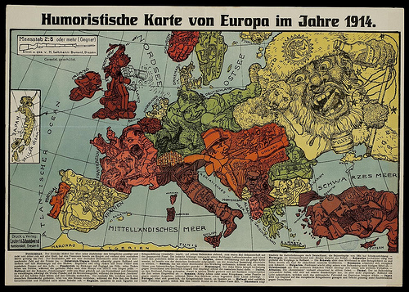

Lecture and section Schedule

Thurs. 9/03: A world made by war? A world unmade by war?

Tues. 9/08: Empires, Alliances, Flashpoints of Conflict
Thurs. 9/10: Averting War…until one didn’t. The anatomy of crises

Section I: Causes of World War I

William James: “The Moral Equivalent of War,” in Memories and Studies, pp. 265-296: : http://nrs.harvard.edu/urn-3:HUL.FIG:001184940.
James Joll and Gordon Martel, The Origins of the First World War (Routledge PB), chaps. 1-4, 8-9 = pp.1-137, 254-307.
Christopher Clark, The Sleepwalkers: How Europe Went to War in 1914 (Harper Collins, 1912), pp. 121-167, 367-562.
Course Website: (1) The July Crisis: Chronology and Documents

Tues. 9/15: Disastrous Rationality: Strategic Choices, 1914-18
Thurs. 9/17: The Logic of Enlargement: New Fronts and New Combatants.

Section II: “Politics by other Means?” Rational Choice in War.
Carl von Clausewitz, On War, Michael Howard and Peter Paret, eds.(Princeton University Press, 1976), pp. 75-99, 113-23, 224-244. http://web.ebscohost.com.ezp-prod1.hul.harvard.edu/ehost/ebookviewer/ebook/nlebk_2009343_AN?sid=56c54bb7-6106-48b5-9f29-0411814eaff1@sessionmgr11&vid=1
Niall Ferguson, The Pity of War (Penguin PB), chap. 10, 12-13 = pp.282-317, 339-94.
Course Website, (2) John Terraine, "The Road to Passchendaele";

Tues. 9/22: Economies and Economic Warfare: Submarines, Blockade, Production

Thurs. 9/24: Art in War and Art for War: Poetry, Posters

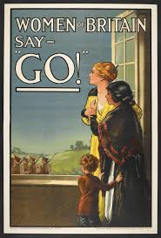

Section III: Writing War
Erich Maria Remarque, All Quiet on the Western Front, PB.

Choose the selections suggested from one of the following memoirs:
Either: Vera Brittain, Testament of Youth (Penguin PB or any ed), Chap. IV, parts 7-10; V, 7; VI, 1-9; VIII, 1-5 +12-14; IX, 9-10; X, 1-4;
OR: Guy Chapman: A Passionate Prodigality, Chap. VII, IX-X, XIII-XIV, XVI, XX, = pp. 92-108, 129-149, 179-208, 221-34, 274-281 (Buchan and Enright PB).

Course Website
(3) Selection of war poems.
(4) Harvard materials (Charles Copeland letters);

Tues. 9/29: The Economics of Warfare: Production, Finance, Labor
Thurs. 10/01: The Harsh Laws of War: Military Justice, Civilian Reprisals, War Crimes

Section IV: Justice in Wartime
Course Website:
(5) Justice Holmes’s opinion in Schenck v. the United States.
(6) Italian court martials

Tues. 10/06: Wilson versus Lenin?
Thurs.10/08: Was the Versailles Treaty doomed?

Section IV: Predictions for Peacetime
John Maynard Keynes, Economic Consequence of the Peace (Penguins PB), pp. 27-55, 187-225, 252-298, Chapter III (The Conference) and Chap. V (Reparation), section 3, and Chap. VII (Remedies).
Ferguson, The Pity of War, chap.14 = pp.395-432.
Course Website:
(7) President Wilson's speeches;
(8) V. I. Lenin, selections;

Tues. 10/13: A New Internationalism? What the League of Nations Did and Didn’t Do. Thurs.10/15: Peace Interrupted: The World Depression and the Rise of Fascism

Section V: Moving on? Varieties of Memory
Jay Winter, Sites of Memory, Sites of Mourning: the Great War in European
Cultural History (Cambridge UP, Canto PB), chaps. 3-4, 7-8, and Conclusion.

Course website:
(9) Ernst Jünger, "Storm of Steel";
(10) Adolf Hitler, "Mein Kampf".

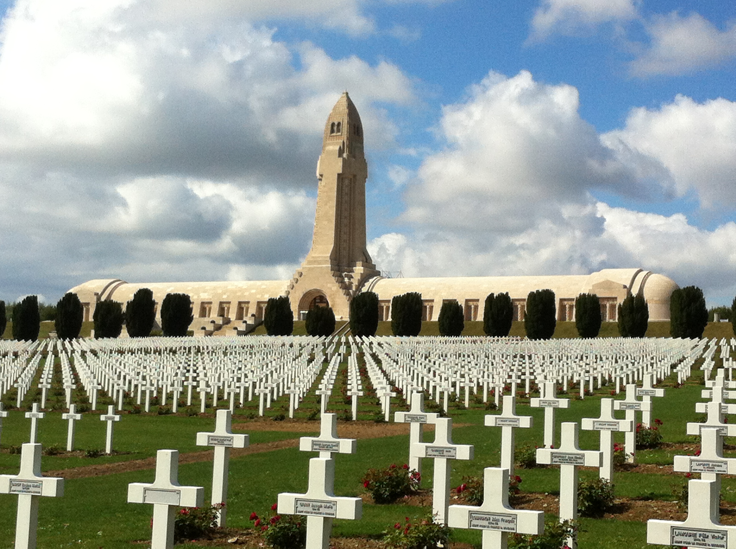

Tues. 10/20: “A low dishonest decade”? Hitler, Stalin, and the Democracies in the 1930s
(Popular Fronts, and the Spanish Civil War).
Thurs.10/22: Upheavals in Asia: 1919-41: China, Japan, and the European Empires

Section VI: Choices for Aggression, Choices for Appeasement
Adam Tooze, The Wages of Destruction: The Making and Breaking of the Nazi
Economy (New York: Viking PB, 2006), pp. 1-33, 203-255, 304-325.

Akira Iriye, Pearl Harbor and the Coming of the Pacific War , pp. 1-105 (Coop)

Selected speeches and documents on the Munich Crisis. See the accompanying list of readings for the web links.
Parliamentary Debates:
https://docs.google.com/document/pub?id=1fWbXnRH4h1IQq2vALaun3UqyutbGM2JIN9_aP2Nrl24

Tues. 10/27: World War II; Four Wars in One?
Thurs.10/29: Strategies and Sacrifices: Britain, Germany, Russia, the U.S., Japan

Section VII: Was Allied Victory Inevitable?
Richard C. Overy, Why the Allies Won (Norton PB) chaps. 1-3 = pp.1-100.

Christopher Bayly and Tim Harper: Forgotten Armies: The Fall of British Asia 1941-1945 (Cambridge: Harvard University Press PB, 2005), pp.1-14, 29-89,. 144-78, 190-217.

Course Website: (11) “Churchill-Roosevelt Correspondence”

Tues. 11/03: Societies and economies at war: Russia, Germany, Japan
Thurs.11/05: Occupation Regimes; Resistance forces

Section: VIII Choices under Occupation
Julian Jackson, France: The Dark Years 1940-1944 (Oxford University Press, 2001), pp. 139-235, 354-81, 475-505
Baily and Harper: Forgotten Armies, pp.208-68, 307-35..

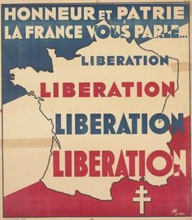

Tues. 11/10: Decisive Weapons in both wars? U-Boats? Gas? Code-breaking?
Thurs.11/12: The Nazi Agenda for the Jews of Europe 1933-45

Section IX: The Holocaust
. Christopher Browning, Ordinary Men: Reserve Police Battalion 101 and the Final Solution in Poland (Harper Collins, 1992), 1-77, 121-189,
Gordon J. Horwitz, Ghettostadt: Lódz and the Making of a Nazi City (Harvard University Press, 2008), pp.1-29, 113-42, 192-247, 287-322. (Reserve)

Tues. 11/17: Technology’s Triumph? The Air War 1936-45
Thurs.11/19: Refugees and DPs

Section X: Should the United States have used the atomic bomb?
John Dower, War Without Mercy, pp. 3-73, 118-46, 293-317. (PB)
Michael Bess, Choices under Fire: Moral Dimensions of World War II (Vintage PB, 2006), chaps. 1, 5, 10=pp.21-41, 88-110, 198-254.

11/24: Planning for Peace? Interallied Relations and conferences 1941-45.
11/26: Thanksgiving Holiday

No Section for this week

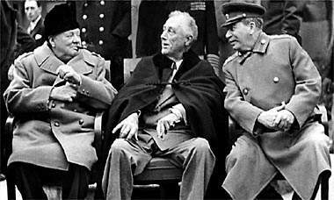

12/01: Punishing Aggression? Nuremberg and War Crime Trials
12/03: Legacies: Cold War, Decolonization, Recovery, Memories

Section XI: Aftermaths
Bess, Choices under Fire, chaps. 11, 13= pp.21-41, 263-86, 309-35.
Robert Moeller, Protecting Motherhood: Women and the Family in the Politics of Postwar West Germany, “Emerging from the Rubble,” pp. 8-37 and notes 229-243.” Link: http://books.google.com/books?id=Zj31HE7P3xQC&printsec=frontcover&source=gbs_ViewAPI#v=onepage&q&f=false

Course Website
13: Richard Titmuss, “Problems of Social Policy”;
14: William Beveridge, Social Insurance and Allied Services";
15: Henry Rousso, “The Vichy Syndrome.”

I. Books Ordered by bookstores and/ or on Reserve*

Christopher Bayly and Tim Harper, Forgotten Armies: The Fall of British Asia (Harvard University Press PB)

Michael Bess, Choices under Fire: Moral Dimensions of World War II (Vintage PB, 2006)

Vera Brittain, Testament of Youth (Penguin PB, 2005).

Christopher R. Browning, Ordinary Men: Reserve Police Battalion 101 and the Final Solution in Poland (Harper Perennial).

Guy Chapman, A Passionate Prodigality (Buchan and Enright PBP).

Christoper Clark. The Sleepwalkers: How Europe went to War in 1914 (Penguin PB).

John Dower, War without Mercy (Norton PB)

Niall Ferguson, The Pity of War (Penguin PB, 1998).

Gordon J. Horwitz, Ghettostadt: Lódz and the Making of a Nazi City (Harvard UP)

Akira Iriye, Pearl Harbor and the Coming of the Pacific War (Bedford PB)

James Joll and Gordon Martel, The Origins of the First World War (Routledge, 2013 –the third edition of the book originally solely written by the late James Joll).

John Maynard Keynes, The Economic Consequences of the Peace. (Serenity PB 2009).

Margaret MacMillan, Paris 1919: Six Months that Changed the World (Random House PB, 2003). Placed on library reserve since page quotient is low, but available from Amazon and bookstores. You can read the British version, HB or PB,published as: Margaret Macmillan: Peacemakers (2003) .

Richard Overy, Why the Allies Won (Norton PB)

Erich Maria Remarque, All Quiet on the Western Front (PB)

Jay Winter, Sites of Memory, Sites of Mourning: the Great War in European Cultural History. (Cambridge: Canto PB, 2000).

Recommended as general surveys but not ordered:
R.A.C. Parker, The Second World War: A Short History (Oxford PB).

Niall Ferguson, The War of the World (Penguin, 2006)

Collins Atlas of World War II (John Keegan ed.) and Collins Atlas of 20th Century History (Richard Overy, ed.)

*Publication data here indicates the most recent paperback publisher available. Students are welcome to read earlier editions if prices are favorable or to purchase them from Amazon.

II. Sources available on line

Section I: :William James: “The Moral Equivalent of War,” in Memories and Studies, pp. 265-296: http://nrs.harvard.edu/urn-3:HUL.FIG:001184940.

Section II: Carl von Clausewitz, On War http://web.ebscohost.com.ezp-prod1.hul.harvard.edu/ehost/ebookviewer/ebook/nlebk_2009343_AN?sid=56c54bb7-6106-48b5-9f29-0411814eaff1@sessionmgr11&vid=1

Section VI: Selected Speeches and Documents for the Munich Crisis
Hossbach Memorandum: November 5, 1937
http://avalon.law.yale.edu/imt/hossbach.asp

Munich Pact: September 29, 1938
http://avalon.law.yale.edu/imt/munich1.asp

Munich Pact : Annex to the Agreement
http://avalon.law.yale.edu/imt/munich2.asp

Munich Pact: Declaration
http://avalon.law.yale.edu/imt/munich3.asp

Hitler’s Response to President Roosevelt’s Peace Message: April 28, 1939
http://proquest.umi.com.ezp-prod1.hul.harvard.edu/pqdweb?index=491&did=95773600&SrchMode=1&sid=1&Fmt=10&VInst=PROD&VType=PQD&RQT=309&VName=HNP&TS=1282323995&clientId=11201

Baillie, Albert, John Fischer Williams and W.W. Paine, ''Letters to the
Editor,'' THE TIMES OF LONDON, pp. 8. Copyright © September 30, 1938.
http://infotrac.galegroup.com.ezp-prod1.hul.harvard.edu/itw/infomark/41/308/122480611w16/purl=rc1_TTDA_0_CS134689598&dyn=63!xrn_1_0_CS134689598&hst_2&bkm_63_1_2_3?sw_aep=camb55135

Churchill, Winston S., ''Our Consciences are at Rest,''
http://hansard.millbanksystems.com/commons/1939/sep/03/prime-ministers-announcement#S5CV0351P0_19390903_HOC_38

Churchill, Winston S., ''Prime Minister,'' http://www.churchill-society-london.org.uk/BdTlTrsS.html

Churchill, Winston S., ''Text of Churchill Speech at Waltham Abbey, Essex,''
THE TIMES OF LONDON, pp. 16. Copyright © March 15, 1939.
http://infotrac.galegroup.com.ezp-prod1.hul.harvard.edu/itw/infomark/41/308/122480611w16/purl=rc1_TTDA_0_CS268907631&dyn=67!xrn_1_0_CS268907631&hst_1?sw_aep=camb55135

Staff, ''Negotiations Continue,'' THE TIMES OF LONDON, pp. 13. Copyright ©
September 5, 1938. http://infotrac.galegroup.com.ezp-prod1.hul.harvard.edu/itw/infomark/42/308/122480611w16/purl=rc1_TTDA_0_CS218444581&dyn=9!xrn_1_0_CS218444581&hst_1?sw_aep=camb55135

Staff, ''Nuremberg and Aussig,'' THE TIMES OF LONDON, pp. 13. Copyright ©
September 7, 1938. http://infotrac.galegroup.com.ezp-prod1.hul.harvard.edu/itw/infomark/42/308/122480611w16/purl=rc1_TTDA_0_CS218444583&dyn=6!xrn_2_0_CS218444583&hst_1?sw_aep=camb55135

Staff, ''The Threat of Force,'' THE TIMES OF LONDON, pp. 13. Copyright ©
September 8, 1938. http://infotrac.galegroup.com.ezp-prod1.hul.harvard.edu/itw/infomark/42/308/122480611w16/purl=rc1_TTDA_0_CS218444584&dyn=12!xrn_1_0_CS218444584&hst_1?sw_aep=camb55135

Staff, ''A Lull in Prague,'' THE TIMES OF LONDON, pp. 13. Copyright ©
September 9, 1938. http://infotrac.galegroup.com.ezp-prod1.hul.harvard.edu/itw/infomark/42/308/122480611w16/purl=rc1_TTDA_0_CS218444585&dyn=18!xrn_1_0_CS218444585&hst_1?sw_aep=camb55135

Staff, ''The Frontiers of Czechoslovakia,'' THE TIMES OF LONDON, pp. 7.
Copyright © September 9, 1938. http://infotrac.galegroup.com.ezp-prod1.hul.harvard.edu/itw/infomark/42/308/122480611w16/purl=rc1_TTDA_0_CS117781289&dyn=15!xrn_1_0_CS117781289&hst_1?sw_aep=camb55135

Staff, ''Prague and the Plan,'' THE TIMES OF LONDON, pp. 13. Copyright ©
September 20, 1938. http://infotrac.galegroup.com.ezp-prod1.hul.harvard.edu/itw/infomark/42/308/122480611w16/purl=rc1_TTDA_0_CS218444596&dyn=23!xrn_3_0_CS218444596&hst_1?sw_aep=camb55135

Staff, ''Map,'' THE TIMES OF LONDON, pp. 9. Copyright © September 22, 1938. http://infotrac.galegroup.com.ezp-prod1.hul.harvard.edu/itw/infomark/42/308/122480611w16/purl=rc1_TTDA_0_CS218444596&dyn=23!xrn_3_0_CS218444596&hst_1?sw_aep=camb55135

Staff, ''Facing the Issue,'' THE TIMES OF LONDON, pp. 11. Copyright ©
September 24, 1938. http://infotrac.galegroup.com.ezp-prod1.hul.harvard.edu/itw/infomark/42/308/122480611w16/purl=rc1_TTDA_0_CS184890168&dyn=29!xrn_1_0_CS184890168&hst_1?sw_aep=camb55135

Staff, ''A Week of Decision,'' THE TIMES OF LONDON, pp. 13. Copyright ©
September 26, 1938. http://infotrac.galegroup.com.ezp-prod1.hul.harvard.edu/itw/infomark/42/308/122480611w16/purl=rc1_TTDA_0_CS218444602&dyn=33!xrn_1_0_CS218444602&hst_1?sw_aep=camb55135

Staff, ''News Report,'' THE TIMES OF LONDON, pp. 12. Copyright © September
27, 1938. http://infotrac.galegroup.com.ezp-prod1.hul.harvard.edu/itw/infomark/42/308/122480611w16/purl=rc1_TTDA_0_CS201536315&dyn=40!xrn_1_0_CS201536315&hst_1?sw_aep=camb55135

Staff, ''Text of Chamberlain Address,'' THE TIMES OF LONDON, pp. 10.
Copyright © September 28, 1938. http://infotrac.galegroup.com.ezp-prod1.hul.harvard.edu/itw/infomark/42/308/122480611w16/purl=rc1_TTDA_0_CS168506172&dyn=43!xrn_1_0_CS168506172&hst_1?sw_aep=camb55135

Staff, ''The Issue Defined,'' THE TIMES OF LONDON, pp. 11. Copyright ©
September 28, 1938. http://infotrac.galegroup.com.ezp-prod1.hul.harvard.edu/itw/infomark/42/308/122480611w16/purl=rc1_TTDA_0_CS184890172&dyn=47!xrn_1_0_CS184890172&hst_1?sw_aep=camb55135

Parliamentary Debates https://docs.google.com/document/pub?id=1fWbXnRH4h1IQq2vALaun3UqyutbGM2JIN9_aP2Nrl24

Gen Ed SW-42 Syllabus as of 8/27/15

