Worksheet Sexual Coercion

- Forced copulations in orangutan
- Watch the video 1 showing the longcall of an prime flanged orangutan male:
- Which insights do you gain from below grafic into the different mating strategies of males in Orangutans (3 sentences per group into the following google worksheet (incl groupnumber)

https://docs.google.com/document/d/1JYROAyZnahmO91D2NzI3k6yzkT4ZDzgnTg6JCgrqmu4/edit?usp=sharing

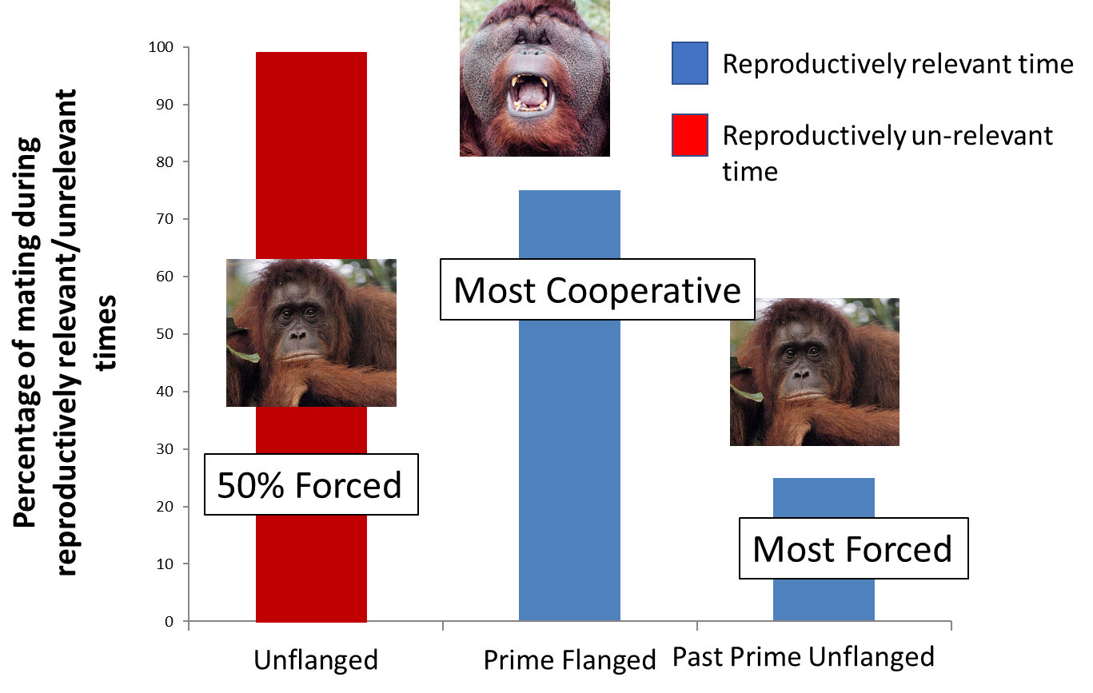

- Harassment / intimidation in chimpanzees
- Watch the 2 chimpanzee videos one showing male mate initiation ad the other one male aggression against a female
Describe in one sentence for each graphic what they reveal about the use of male aggression as a male mating strategy in chimpanzees. post it with group-number on https://docs.google.com/document/d/1JYROAyZnahmO91D2NzI3k6yzkT4ZDzgnTg6JCgrqmu4/edit?usp=sharing

A)
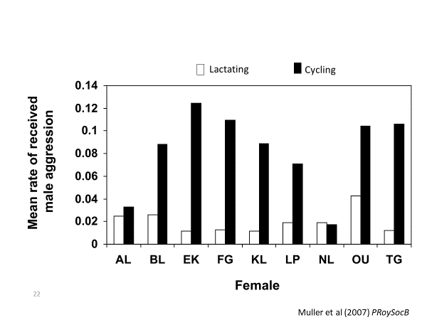
B)
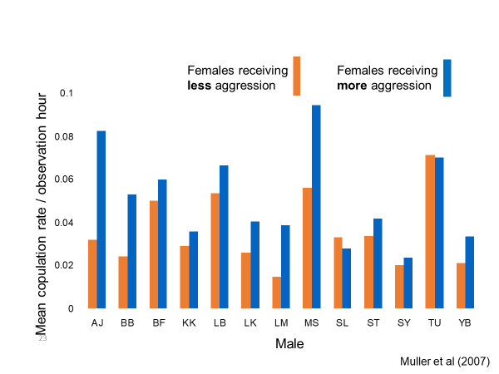

C)

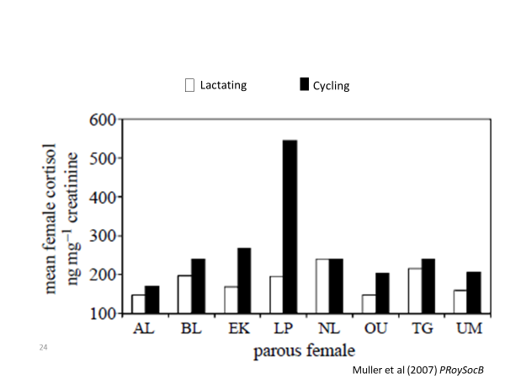

- Herding in Hamadrias baboons
How would you expect the relationship between received aggression by females and her distance to leader male to be, if males do herd females of their harem? post one sentence into https://docs.google.com/document/d/1JYROAyZnahmO91D2NzI3k6yzkT4ZDzgnTg6JCgrqmu4/edit?usp=sharing

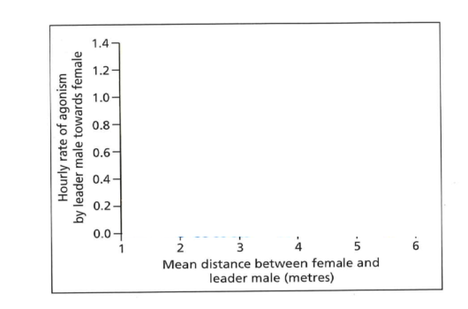

- Sequestration and consortships
In chimpanzees and other primates males try to lure and force females away from other males. Below you see a graphic that shows in red the number of offspring males of a given rank have sired. Can you see some indication of the occurrence of consortships?
https://docs.google.com/document/d/1JYROAyZnahmO91D2NzI3k6yzkT4ZDzgnTg6JCgrqmu4/edit?usp=sharing
