Worksheet male-female friendships in baboons

- Results of study on proximity between female and male friend. Which hypothesis (infanticide protection vs mating investment) is supported with these data? Type your response into https://docs.google.com/document/d/1IzqVRHDR8v-wBoqwspWKcKkIan0AxCcn3daJxHRoMDY/edit?usp=sharing

Percentage time in proximity

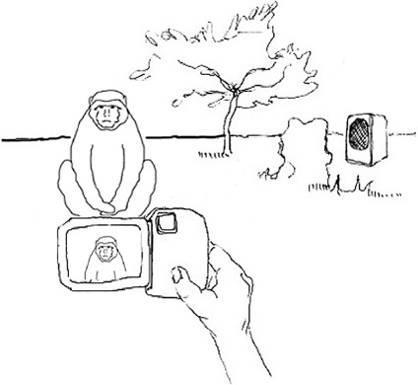
- Playback experiments A and B to femal distress scream. What do the resullt show (Control male is random male and male friend is friend to random female)? Type your answer into https://docs.google.com/document/d/1IzqVRHDR8v-wBoqwspWKcKkIan0AxCcn3daJxHRoMDY/edit?usp=sharing

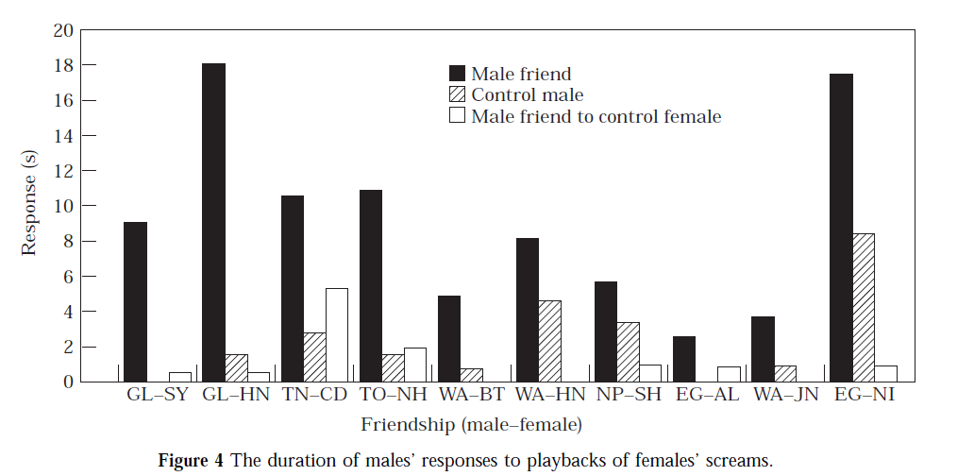

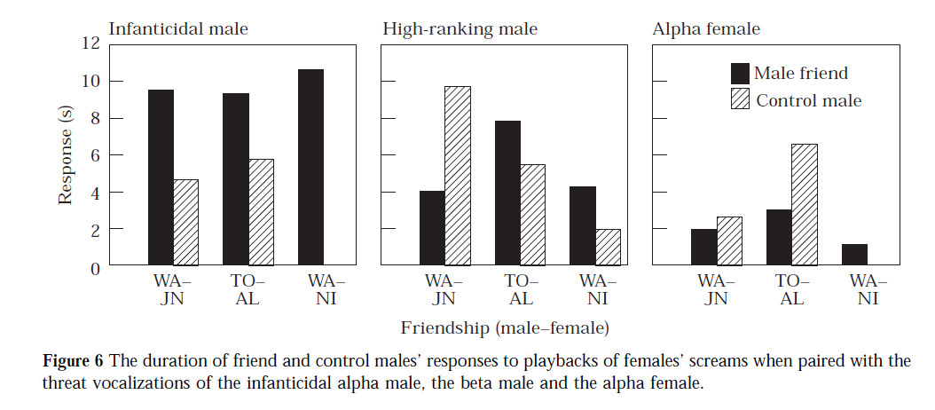
B)

- Which result do you think are more convincing 1) or 2)? Why? Type your response into https://docs.google.com/document/d/1IzqVRHDR8v-wBoqwspWKcKkIan0AxCcn3daJxHRoMDY/edit?usp=sharing

