Logic Model Template
Companion document for Introduction to Logic Models Digital Unit

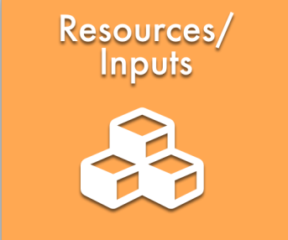 | 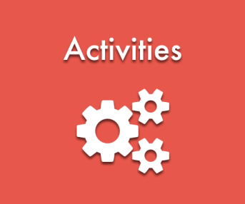 | 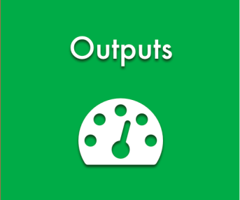 | 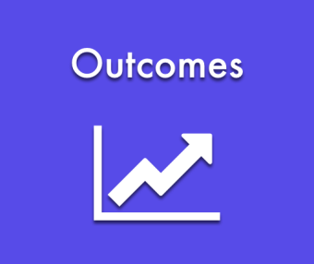 | 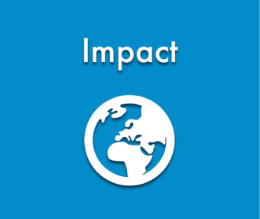
Resources are needed to support the solutions the program proposes; activities depend on resources. | Activities are those actions planned to bring about intended results. | Outputs provide evidence of service delivery. They describe the size and scope of what the program delivers or produces. | Outcomes in a logic model are the short-term and long-term results. | Impact is the set of changes you expect as a result of your activities, 7-10 years after the work is underway.
Reference: W. K. Kellogg Foundation. "Logic model development guide." Michigan: WK Kellogg Foundation (2004). Available with other resources at: https://www.wkkf.org/resource-directory/resource/2006/02/wk-kellogg-foundation-logic-model-development-guide

